**The C10K problem:** It's time for web servers to handle ten thousand clients simultaneously.

Ngnix written in C

What is ngnix? NGINX is a free, open-source, high-performance HTTP server and reverse proxy, as well as an IMAP/POP3 proxy server. NGINX is known for its high performance, stability, rich feature set, simple configuration, and low resource consumption. NGINX is one of a handful of servers written to address the [C10K problem](http://www.kegel.com/c10k.html). Unlike traditional servers, NGINX doesn’t rely on threads to handle requests. Instead it uses a much more scalable event-driven (asynchronous) architecture. This architecture uses small, but more importantly, predictable amounts of memory under load. Even if you don’t expect to handle thousands of simultaneous requests, you can still benefit from NGINX’s high-performance and small memory footprint. NGINX scales in all directions: from the smallest VPS all the way up to large clusters of servers.

Ngnix: It can be work like webserver, and proxy. >> Webserver. >> Load balancing. >> Backend routing. >> Caching.

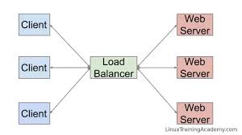

Current architecture:

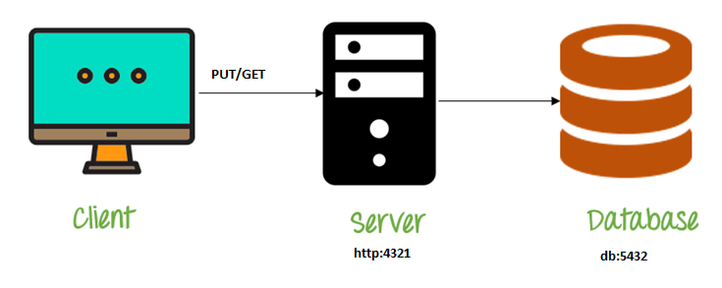

Ngnix as load balancer:

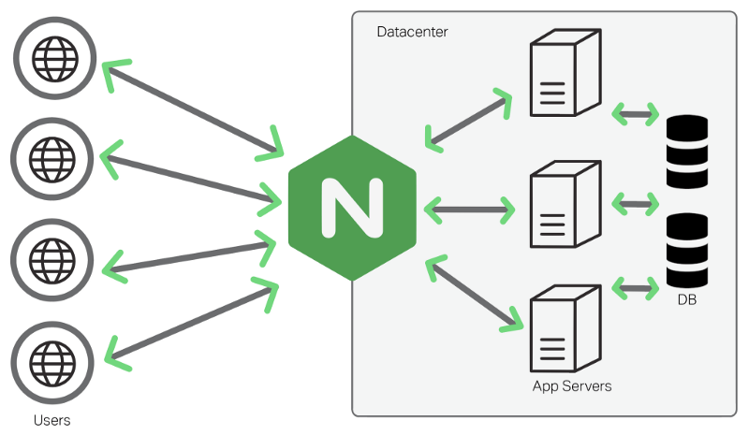

Algorithm for load balancing: round robin.

Note: Anything in front of ngnix is called front end, anything after ngnix called backed.

OSI Model: Layer 4 vs Layer 7 load balancing

